Assignment 5

3/12/2021

1. Difference between Phong and Gouraud shading?

The Gouraud shading model interpolates colors at each pixel. The Phong shading model interpolates vectors between 2 points that then get passed to the fragment shader to be used in the Phong Reflection Model calculations.

With Gouraud shading, you use the Phong Reflection Model to calculate the color for your vertices based off the different light values (ambient, diffuse, and specular). However, for the inside of the polygon, you just interpolate the colors based off of the colors of the vertices. This can lead to less realistic shading because, ultimately, the colors inside the polygon aren’t determined by the light hitting the polygon but by an estimation of what the color would be based off of the vertices it sits between.

With Phong shading, you also still calculate the color for your vertices based off the Phong Reflection Model. Where it differs from Gouraud, though, is that you also do this for every pixel. Rather than interpolate the colors between your vertices, you interpolate the vectors for every point within the polygon. These estimated vectors are then passed to the fragment shader which uses them in the Phong Reflection Model to calculate light values for the given points in the polygon. This leads to more realistic shading because you are essentially doing light calculations to determine color not just for your vertices, but for every point in the polygon as well.

Gouraud:

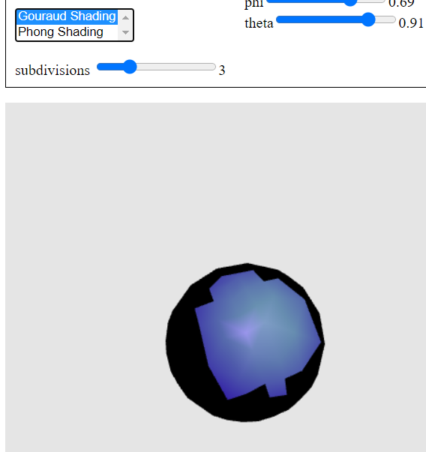

Phong:

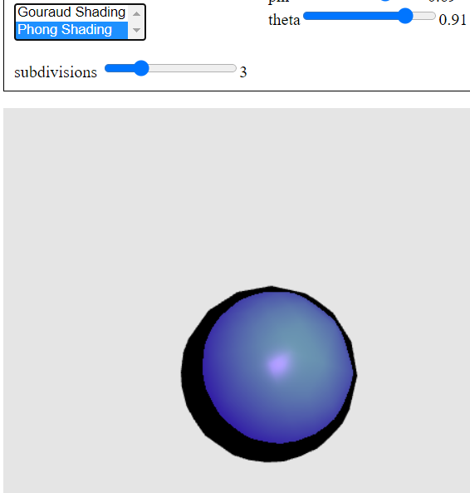

With Gouraud at a smaller amount of vertices, you have a much rougher shading than Phong at the same number of vertices.

1. List and describe non-physical components of Phong Reflection Model
2. The H vector in the specular term – this is made because recalculating the R vector is very computationally expensive and we can get a good enough estimation using H instead.
3. The specular term – for specular highlights we assume the surface is smooth, however for diffuse terms we assume the surface is rough. This assumption is made because, without specular highlights, the object we’re modeling can look 3D but will look dull with no reflected light.
4. The diffuse term – we assume the surfaces are perfectly diffuse. This is done because the object then fits into a model which can be used to calculate the diffuse term of light very easily using Lambert’s Law.
5. The ambient term – we assume that the ambient light is the same intensity for every point on the object. This is computationally efficient because we then don’t need to constantly recalculate the ambient term